Network and Spatial Analysis

Descriptive Analytics: Data Visualization and Storytelling with Data

# Geospatial Analysis

*Geospatial visualizations* are important for identifying positional trends and patterns when geographic and spatial data are available. The creation of these visualizations, which typically are plotted using cartographic coordinate systems, are often augmented by external geospatial data.

As an example, consider the flow of goods between cities where only the locations of the cities and quantity of goods being transferred are known. Impediments to this flow such as oceans, national boundaries, mountain ranges, and other geographical features can impact transportation costs, which in turn can affect the optimization calculations carried out for logistical planning. Simple straight-line distance calculations would not be appropriate. For instance, two cities that are not far apart geographically might be separated by a mountain range that increases both the distance and time required to travel between them.

In this manner, a visualization of geospatial relationships can provide an information-rich environment for manipulating and intuitively analyzing data having positional and interconnected attributes that are not readily evident from the raw data alone.

Geospatial visualizations are useful in many domains including:

* **Epidemiology**: Analyzing the spread of a virus during a pandemic through contact tracing can be facilitated by mapping the locations of infected individuals. The 1854 Broad Street cholera outbreak in England due to contaminated water sources provides an excellent example of the usefulness of geospatial visualization.
* **Civil engineering**: By taking into account geographic and population factors, engineers can plan new highways and bridges that minimize negative impacts on surrounding communities while simultaneously increasing traffic flows.
* **Transportation and logistics**: Optimal warehouse locations and shipping routes depend on the location of the population centers to be served. Through the analysis of geospatial data, planners can determine precisely where warehouses should be situated and then select the corresponding best shipping routes.
* **Sales and marketing**: Customer conversion rates often vary by geographical region, accessibility to retail outlets, local competition, and other factors. With the help of geospatial analyses, point-of-sale and marketing campaigns can be localized to better fit the characteristics of specific populations.
* **Real estate:** As the saying goes, real estate is about “location, location, location.” Mapping the area surrounding particular properties is critical not just for residential real estate, but for corporate real estate, as well. For instance, the location of a company’s headquarters has implications in terms of brand identity, potential hiring opportunities, the applicability of tax laws, employee commute times, etc. On an aggregate scale, investors and those who trade in real estate portfolios (e.g., commercial mortgage-backed securities) can use maps to assess the value of their real estate holdings by looking at regional occupancy rates, rental rates, demographics, and other characteristics of those communities.
* **Politics, policy, and governance:** Election maps are used to study political leanings and voter outcomes on a region by region basis. A common way for candidates to assess their campaign strategies is by analyzing the evolution of election outcomes in and around their respective geographical areas over time.
* **Economics:** Economic research often depends on understanding the flow of goods, services, resources, and technologies. This research can benefit from layered geospatial mappings and simulations that focus on population, resource availability, transportation, etc.

## Data Preparation

Spatial data comes in many forms. It can be simple, such as addresses and coordinates, or complex, such as shapefiles or keyhole markup language (KML) files (geospatial data containers having considerable information about the features in and around the points of interest). When data contains geographical or spatial information, it has additional meaning as a *spatial dataset*.

Spatial information can be either numeric or categorical. For example, data can exist in the form of country-specific postal addresses, in which the combination of numbers, street names, city names, country names, and postal codes (such as the ZIP codes used in the U.S.) generally specify a unique physical location. Additionally, each location has a corresponding set of GPS coordinates that can be used for calculating distances among those locations. Coordinates within a particular bounded region—such as those that lie within the State of California—can be grouped together to form a categorical variable specifying whether a given location is inside or outside of California. Additionally, one can roll up locations into larger regions such as cities into counties, counties into states, states into nations, and so forth.

When plotting data on a map, you must determine whether you need an accurate representation of angles, distances, or areas. Keep in mind that it is challenging to represent geospatial coordinates accurately because you are effectively mapping points on a three-dimensional surface (a sphere) to a two-dimensional surface. Ignoring elevation for a moment, this mapping is typically done via a projection. The Earth is an oblate spheroid so making an accurate projection is not by any means trivial! No projection can preserve shapes, angles, and areas simultaneously. There is always a tradeoff, so it’s important to remember that the projection you choose must preserve the specific features that are important for your analysis.

There are many projection systems; the most important ones are:

* **Mercator**: This projection preserves angles and shapes but distorts the area substantially. (It is the most common projection and most people are familiar with it.)
* **Gail/Peters**: This projection preserves areas but distorts shapes and angles.
* **Lambert conformal conic:** This projection preserves angles and shapes but distorts areas.
* **Albers-equal area:** This projection preserves areas but distorts angles and shapes.

The projection system you use dictates the type of information that can be conveyed through the corresponding visualization. For instance, if the distance between points is important, a projection that preserves areas is probably your best choice.

## Layers

Maps are built using layered applications of the grammar of graphics. Maps consist of:

* A projection coordinate system
* Boundaries and regions delineated by map tiles
* Additional layers of mapping tiles (as needed)
* User data mapping your values of interest to position, size, color, shape, or to any of the aesthetics of the other map layers

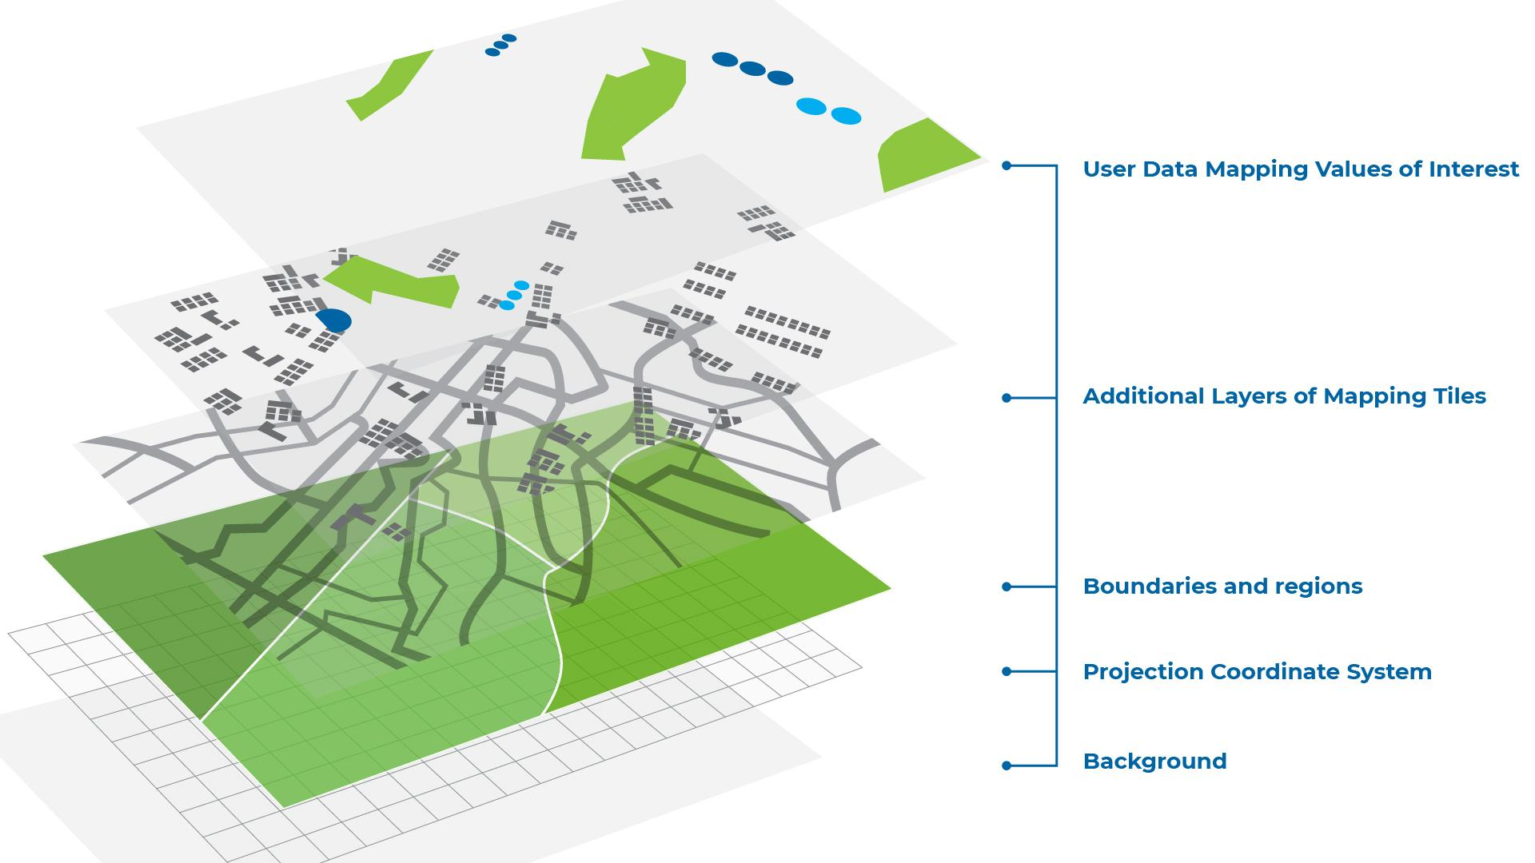

*Figure 1: A map showing the layered application of grammar of graphics*

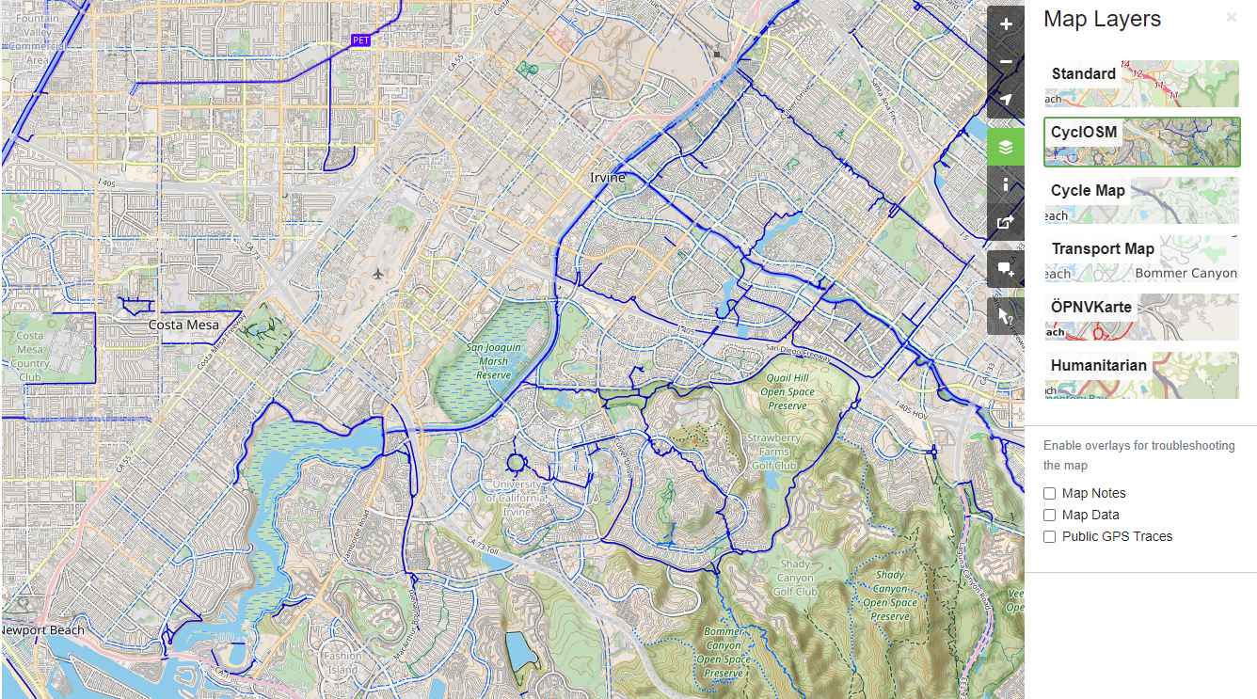

*Figure 2: Two-dimensional map of an urban region showing several layers including streets, bicycle lanes, and public transportation routes (From Open Street Maps* [*https://www.openstreetmap.org*](https://www.openstreetmap.org)*)*

Once the projection and coordinate system are established, you layer information and data on top of the map (Figures 1 and 2). Typically, public map data such as terrain, road, and elevation data is provided as map tiles. This information is then imported directly into your mapping software or through code as tilesets (sets of map tiles).

*Map tiles* are simply the rendered regions of focus scaled to your coordinate system. Many resources are available to provide other types of potentially useful information such as traffic, weather, transportation, or points-of-interest data. This information can be layered onto any user-created map (Figure 3).

*Figure 3: Sample elevation map showing the Earth’s surface in three dimensions and two specific locations denoted by markers*

Data can be mapped in at least 3 different ways:

1. You can use a marker like an abstract pin or icon (Figures 3 and 4).This is probably the most literal use of positional data on a map and is used when relative position, distances, and angles are important. Other attributes of the pin or icon can be mapped to data values to show additional measures and dimensions, as well.

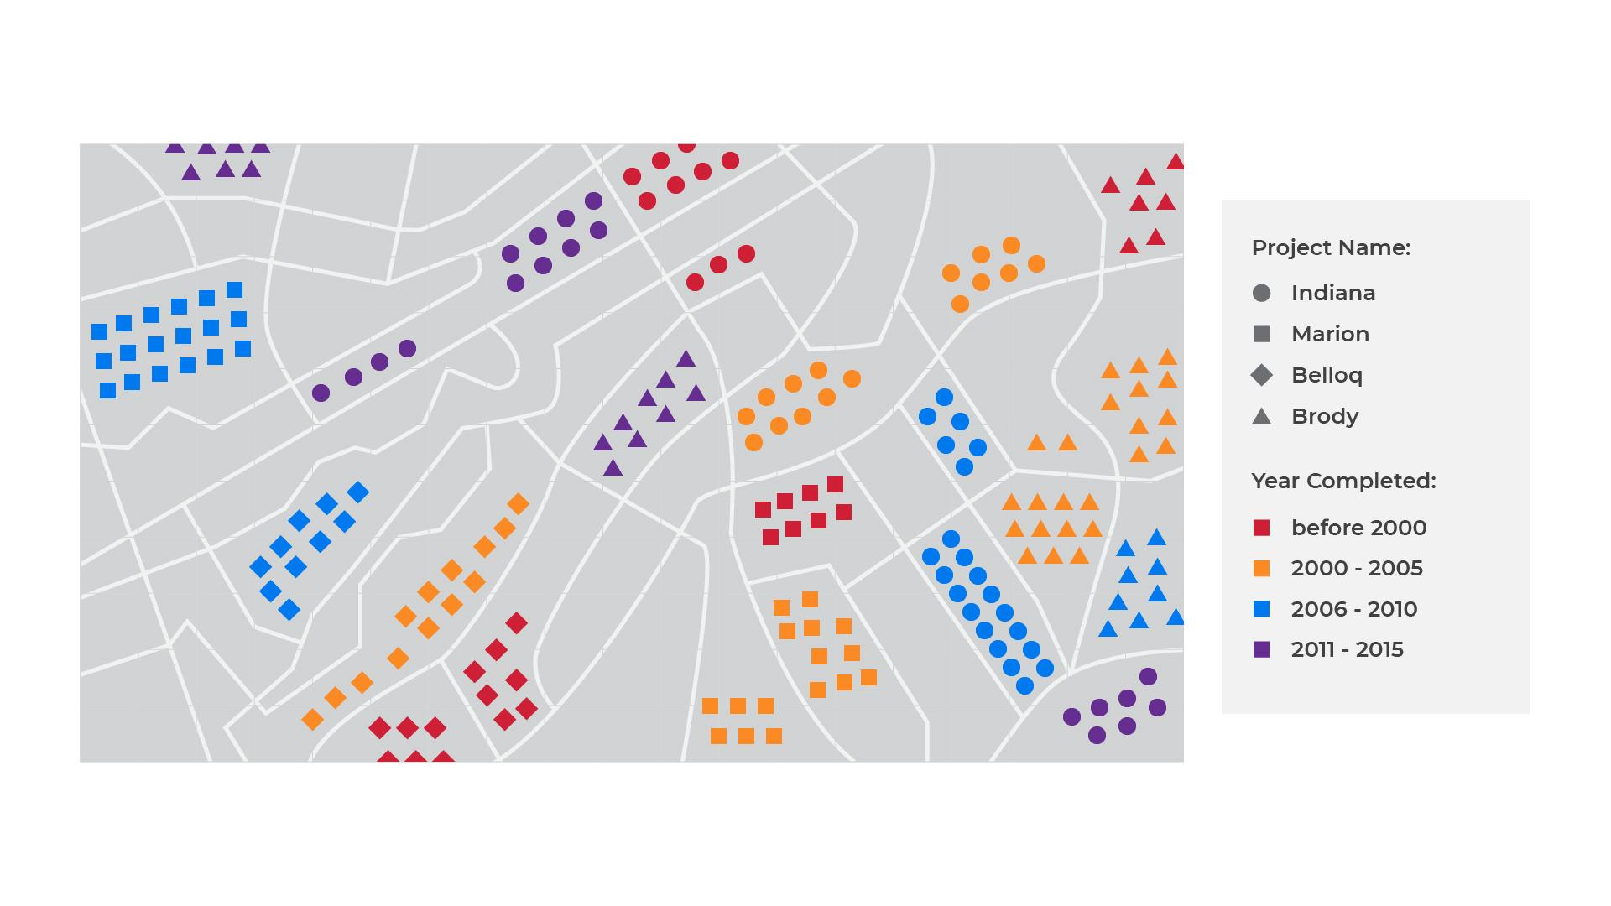

*Figure 4: Map using markers of different shapes and colors to indicate the location, project name, and year of construction for a set of projects*

1. Areas within the borders of the region can be colored based on the data to show differences or similarities in quantity values (Figure 5). These types of maps are called *choropleths* and provide a quick way to visually compare regions at varying levels of granularity. 

*Figure 5: A choropleth, in which thee map uses colors to show differences in unemployment rates by state*

1. If geographic accuracy is not a priority, we can apply the grammar of graphics to map data values to different aesthetics of the map itself like size and symbol (Figure 6). This leads to visualizations called *cartograms*where the map is intentionally distorted by the data to more clearly show differences and patterns.

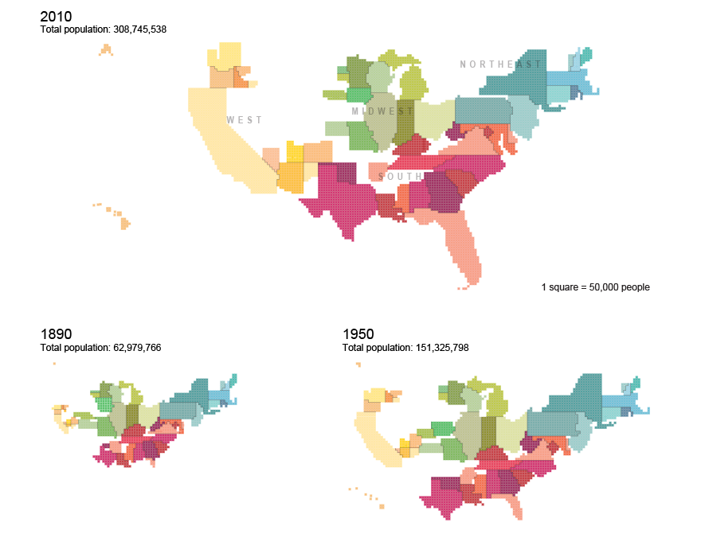

*Figure 6: A cartogram, in which the map is deliberately distorted to call attention to specific differences and patterns (From US Census Bureau* [*https://www.census.gov/dataviz/visualizations/021/*](https://www.census.gov/dataviz/visualizations/021/)*)*

## Visual Exploration

One of the advantages of geospatial analysis is that it allows analysts to overlay multiple dimensions and measures making it easy to observe the interplay of multiple variables simultaneously. Most mapping software or software libraries create interactive visualizations where functionality such as search, zoom selection, dragging, level-of-detail specification, etc. are automatically available. Being able to hide or show layers provides an additional level of control for filtering the amount of information displayed.

The real power of geospatial analysis lies in the additional context that having a “human-in-the-loop” brings to geospatial visual analysis. Much contextual or even anecdotal information can be brought to light only when subject matter experts interact with geospatial visualizations.

# Network Analysis

*Network analysis* provides a general approach for analyzing spatial data. In fact, just about any geospatial analytics problem can be abstracted as a network analysis problem. In addition, network analysis can represent non-spatial abstractions such as dependencies, relationships, states, and processes.

In general, network analysis (called *graph analysis* in some disciplines) encompasses a range of techniques for analyzing network structures. A network is composed of nodes and links such that pairs of nodes are connected to each other by links (see Figure 7). (You can think of cities as nodes and the roads between them as links.) A link can also carry a weighting factor that accumulates as you traverse the network. For example, a road connecting two cities can have a weighting factor corresponding to its length (or the distance between the cities).

One reason for framing problems as networks is that there are a number of solutions to network problems available from other disciplines, including network traversal algorithms from computer science, reasoning systems from logic and computation, and mathematical equivalences and calculations from discrete mathematics. All of these are applicable to any situation that can be represented by a network.



*Figure 7: A simple network (graph) with six nodes connected by links*

A full explanation of network analysis could fill several textbooks. Several recommended books for applications and theory of network/graph analysis include:

* Brath, R. and Jonker, D. (2015). *Graph Analysis and Visualization*
* Menczer, F., Fortunato, S., and Davis, C. (2020). *A First Course in Network Science*
* Zinoviev, D. (2018). *Complex Network Analysis in Python*

As an oversimplification, the primary calculations performed on networks can be distilled into:

* The *shortest path* or *path of least cost* (if the links have costs associated with them)
* *Centrality*, which measures the relative importance of each node in the network based on criteria such as the number of links it has (*degree*), the frequency with which the node falls on the shortest path between two other nodes (*betweenness*), or the average length of the paths from the node to all the other nodes (*closeness*).
* *Density,* which measures how connected the graph is. An empty graph would have a density of 0 while a fully connected, undirected graph would have a density of 1. (An *undirected graph* can be traversed in both directions.)

Network analysis is useful for:

* **Social media analytics**: Understanding social networks helps marketers target cliques and key influencers more effectively, and also helps estimate reach.
* **Recommendation engines:** Collaborative filters benefit from a better understanding of the connections that users have with others who have similar preferences, which thereby improves recommendation results.
* **Search engines:** Google’s Pagerank algorithm uses network analysis to calculate the ranking of a website based on the number of other websites linked to it.
* **Geospatial analysis:** Determining the optimal route between two geographical points is a network traversal problem where nodes are points of interest and weighted links are roads, bike paths, and walkways that connect them.
* **Civil engineering:** Simplifying complex geospatial maps by converting them into large connected networks allows the determination of optimal pathways for infrastructure improvements. This is useful for large civil engineering projects.
* **Defense and intelligence:** The search for key members of terrorist organizations can be reframed as a network problem. By following the cash transactions (links within the network) of various entities (nodes), the centrality of the network might indicate key targets for enhanced surveillance or extraction.
* **And much more...**

## Data Preparation

The basic inputs for conducting a network analysis are:

A set of nodes with each node having a:

* Node name
* Group of other attributes or variable properties

A list of links with each link represented by the following tuple:

* Source node
* Target node
* (Optional) Weight or cost associated with the relationship between the source and target nodes (can be either directed or undirected)

As an example, we can create a simple visualization of the structure of the S&P 500 monthly returns with the goal of showing the relationships among companies in the US economy. If we set each company in the S&P 500 as a node and the price correlation between pairs of companies as links, we arrive at Figure 8.

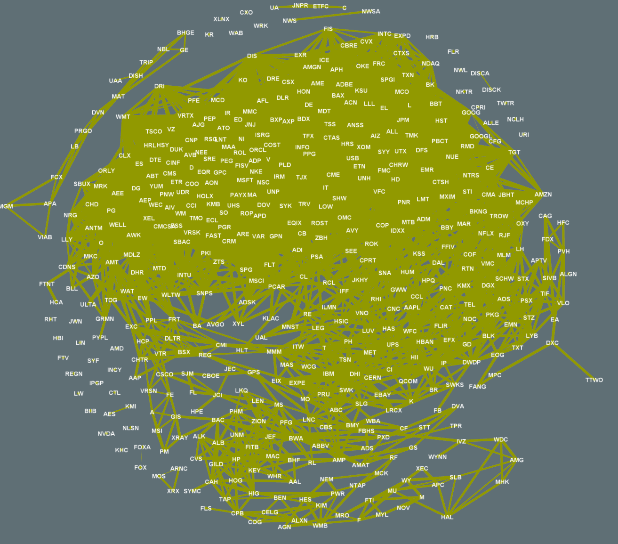

*Figure 8: A graph in which corporations are represented by nodes and the price correlation between pairs of companies is represented by links.*

Tightly coupled relationships exist among these companies as they receive and make payments for services and goods among themselves, utilize each other’s hardware and software solutions, make investments (into factories, buildings, technologies), etc. By mapping these relationships to a network diagram, we can begin to see various levels of dependence and cross-sector relationships. We can see how a supply disruption at one company might impact inventory levels at other, dependent companies. We can view how an economy depressed by inflationary forces might actually benefit a select few companies that provide commodity resources to the rest of the market.

## Layers

Just as we applied layers to geospatial maps, we can also apply layers to network diagrams. For instance, the aesthetics of a node’s size, symbol, and color can be mapped to different variables. In particular, a node can have certain aesthetics that depend on graph-based calculations such as counting the number of connections between the node and other nodes (called the *degree*). Nodes with more connections could merit closer inspection.

Similarly, the weight, style, color, and shape direction of links can be used to represent scale values of the relationships between nodes such as distances, costs, or statistical properties such as correlation.

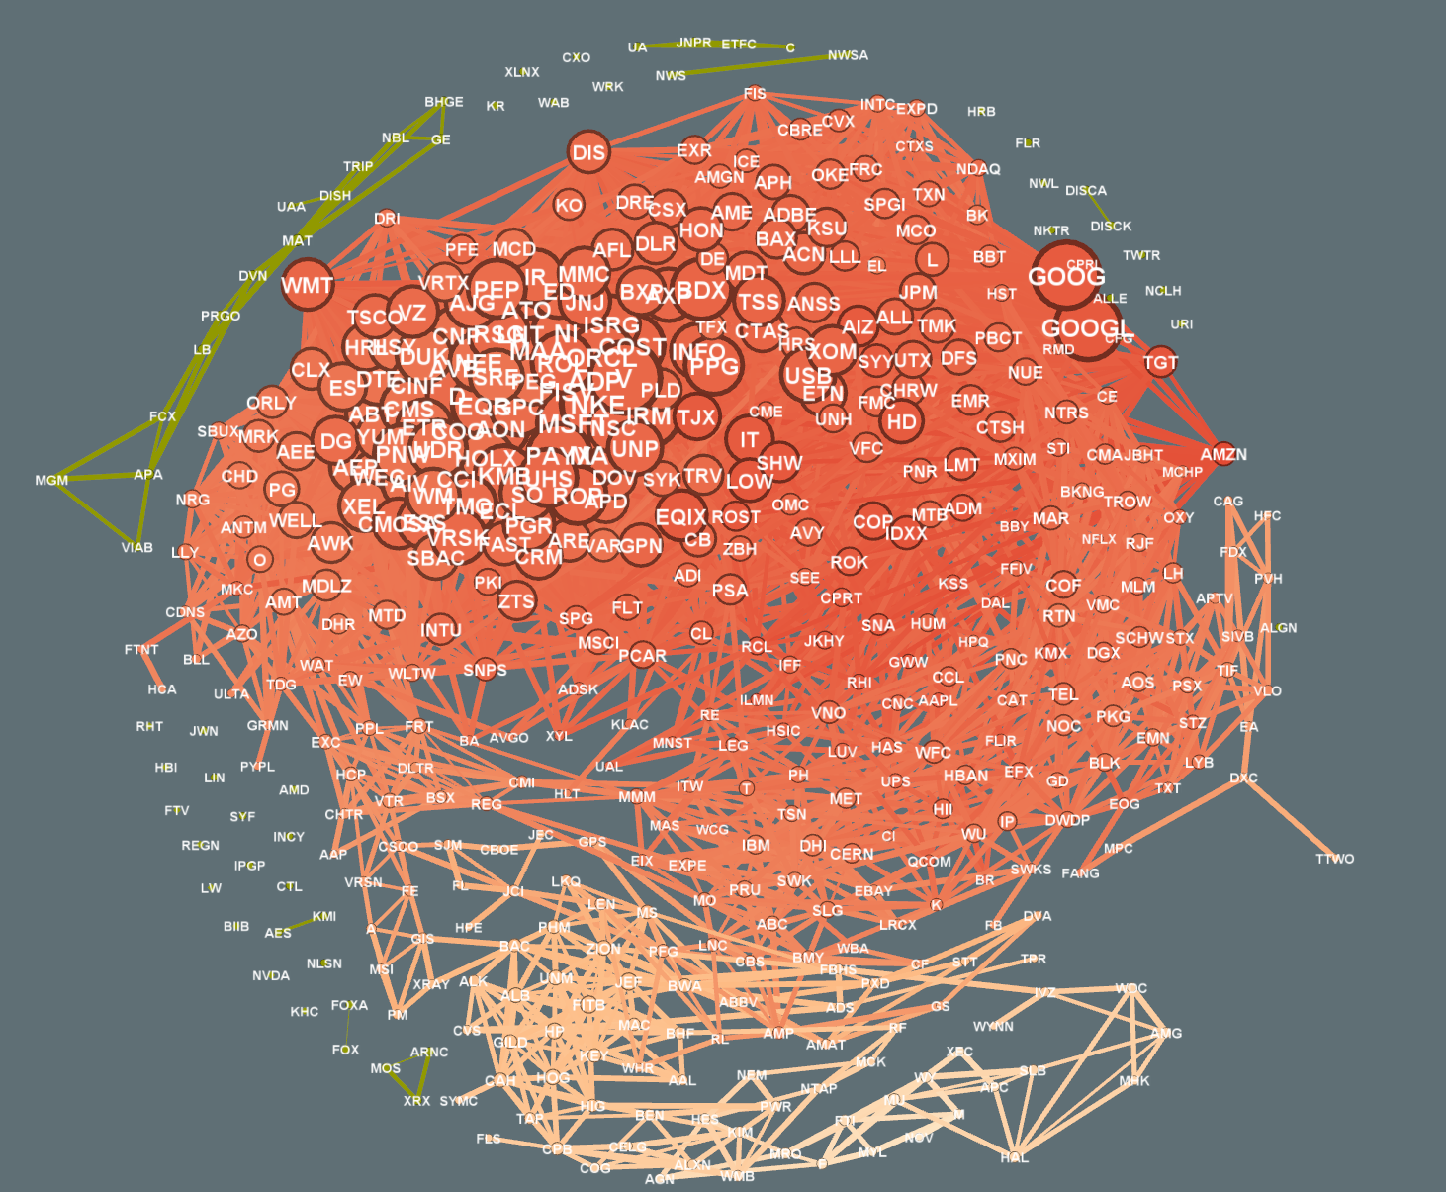

*Figure 9: The graph of Figure 8 enhanced by various aesthetics applied as layers to nodes and links*

## Visual Exploration

Network visualizations create unique virtual representations that enable viewers to navigate through abstract data concepts in a familiar and intuitive data space. The same interaction functionality available with geospatial visualizations grant viewers the power to understand the structure of network data. Brushing and linking in particular are very useful for looking at subgraphs of large networks and the data values associated with those subgraphs’ nodes and links.



*Figure 10: Dynamic visual exploration of a network*

The ability to physically manipulate a network without rearranging the structure provides a tangible way for looking at the data from multiple angles.

One disadvantage of geospatial and network visualizations is that the required level of interactivity is rather high. In order to get the most utility from the often complex task of data preparation for these specialized visualizations, it’s desired to allow users to have a free range of interactions with the data because this increases the likelihood of discovering hidden structures or patterns. Because of potential limitations associated with static visualizations (such as not being able to enlarge, pan, or add levels of detail) designers are forced to make a priori choices about the visualization that should be viewed.